# Spotlight Developer Interview - Technical Tests

Provide partial or full solutions to as many problems as you can, **in any order.**

***Take up to 90 minutes to complete the test.* *You are not expected to complete all questions.***

You may use Google, MSDN, or any other resources you would normally use whilst developing software. Be prepared to discuss and justify your solutions. Solutions should be submitted as a ZIP file containing your code. Make sure everything necessary to run your solution is included.

Some questions are harder than others; each question has a point score according to difficulty. Candidates are graded on total overall points.

By taking this test, you are agreeing not to share the contents or calculations with other agencies or candidates, nor will you publish it elsewhere. Failure to comply with this will immediately invalidate your application (and we do tend to find out about these things!).

Thanks and Good Luck!

## Question 1: FizzBuzz (10 points)

Create a C# console application that, when executed:

1. Prints the numbers from 1 to 100, inclusive
2. Each number should be printed as an integer, on its own line
3. For numbers that are a multiple of three, print "Fizz" instead of the number
4. For numbers that are a multiple of five, print "Buzz" instead of the number
5. For numbers that are multiples of both three and five, print "FizzBuzz" instead of the number
6. After printing the final number, the program should pause until the user presses any key, and then exit.

## Question 2: Washed out photos (15 points)

A professional photographer has reported that their photographs are appearing washed out when they have been uploaded to our website and converted to thumbnails. This is only affecting a small proportion of the photos.

The code which generates the thumbnails is in the LossOfColorBug project in the ZIP file you have been sent. Please fix the reported problem but make sure that the modifications don’t break images that are fine at the moment.

## Question 3: Tic-Tac-Toe (20 points)

Implement a two-player "noughts and crosses" (aka "tic tac toe") game that runs in a web browser. Both players will sit at the same computer – we're not looking for web-sockets or anything.

* The game starts with a blank 3x3 grid
* Players take it in turns to make a move.
  + When starting a game, either player may start the game by making the first move; once the game is in progress, the game should force players to take turns.
* Players make a move by clicking a blank grid square; this will mark a **O** or **X** in that square as appropriate. Once a move is made, it cannot be taken back.
* The first player to claim three squares in a row (horizontal, vertical or diagonal) is the winner. When this happens, your program should inform the players who has won, and allow them to start a fresh game.
* If the game reaches a point where neither player can win, your program should inform the players that the game is a draw, and allow them to start a fresh game.

**You do not need to implement an "AI" computer player. Your program should provide the game board and act as "referee" but will not be expected to make any moves.**

## Question 4: ASP.NET MVC Bug Hunt (10 points)

There is an ASP.NET MVC 4 web application called “MvcTest” in the the ZIP file you have been sent. There's two bugs in this web application. Please find them and fix them.

### What's supposed to happen:

**/Home/Index** (the default view) will ask you your name. When you enter your name and press "Go", the application will display **/Home/Welcome** This view should welcome you by name, and tell you the current date, in the format "January 4, 1987"

### What to do:

1. Identify the two bugs. Determine whether they are currently covered by failing tests or not.
2. If a bug IS currently covered by a failing test, then fix the code.
3. If the bug is NOT currently covered by a failing test, then
   1. Write a new test that reproduces the bug
   2. Modify the code so that your new test passes.

**DO NOT MODIFY ANY EXISTING TESTS.**

## Question 5: Concerts (10 points)

You have been asked to build a software application to sell tickets to live music concerts happening in the United Kingdom. Your customer would like to:

* List all forthcoming shows by a particular band
* List all forthcoming shows in a particular city
* List all forthcoming shows for a specific venue
* Display the details of a specific show – the band who are performing, the start time and the venue.
* Display ticket prices for a specific show
* Display a list of customers who have purchased tickets for a specific show

**Steps**

1. Create a relational database in Microsoft SQL Server to store the information your application will use.
2. Write queries to return the data required for each of the requirements listed above.

Submit your solution as a set of SQL scripts that will create the database, and a separate file containing the queries required in part 2.

## Question 6: Limerick (10 points)

Write a C# console application called **reverser.exe** that will read a text file and create a new text file containing the input with the order of the lines reversed. Given the following input example – limerick.txt

From an ancient Egyptian papyrus,  
A professor translated a virus.  
It was rather terrific,  
For an old hieroglyphic,  
His computer was cursed by Osiris.

You should run your program by running:

**C:\>reverser.exe limerick.txt reversed.txt**

This should create the output file reversed.txt containing the following content:

His computer was cursed by Osiris.  
For an old hieroglyphic,  
It was rather terrific,  
A professor translated a virus.  
From an ancient Egyptian papyrus,

Your implementation should be accompanied by unit tests verifying that each element of the program behaves correctly. **Unit tests must be able to run without file system access –** your tests must prove the correctness of your implementation without reading or writing any files.

## Question 7: Wordsearch (10 points)

There is an ASCII text file of English words and names available at:

<https://dl.dropbox.com/u/7543760/wordlist.txt>

Write a C# console application that takes two arguments – a required word-length, and a search word – and lists, in alphabetical order, every word from the online word list that matches the specified length AND contains all the characters from the search word, in order but not necessarily consecutively.

**Your program should download a fresh copy of the word list from the above URL each time it is run.**

For example:

**C:\>wordlist.exe 9 html**

Should print to the console all the nine-letter words containing the letters "h", "t", "m" and "l", in that order. In this example, your output should be:

nachtmaal  
shtreimel  
wheatmeal

**C:\>wordlists.exe 6 fish**

Should list all six-letter words containing "f", "i", "s" and "h", in that order:

elfish

famish

Farish

farish

fetish

Fifish

fifish

fikish

finish

fished

Fisher

fisher

Fishes

fishes

fishet

fivish

foeish

foxish

Frisch

frisch

fumish

oafish

offish

wifish

## Question 8: Mandelbrot (25 points)

Build an ASP.NET web application in C# that displays a web page containing a 400x400 pixel rendering of the Mandelbrot set. Clicking anywhere on the set should zoom in by a factor of 2, centred on the coordinates of the mouse click. The page should display the current coordinates and zoom level.

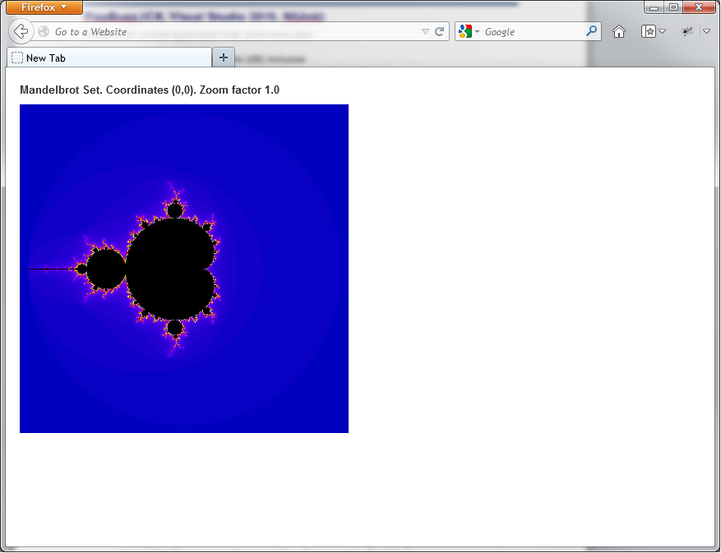 🡪 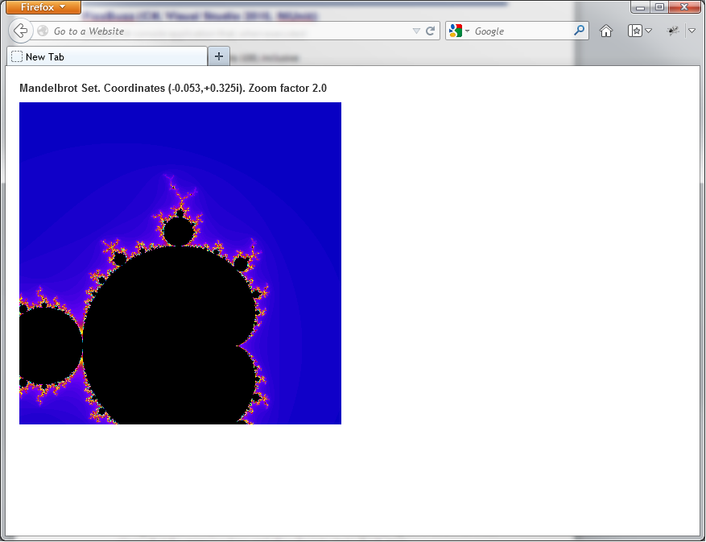

**Your solution must not require JavaScript to be enabled in the browser.**